**Insert Document:**

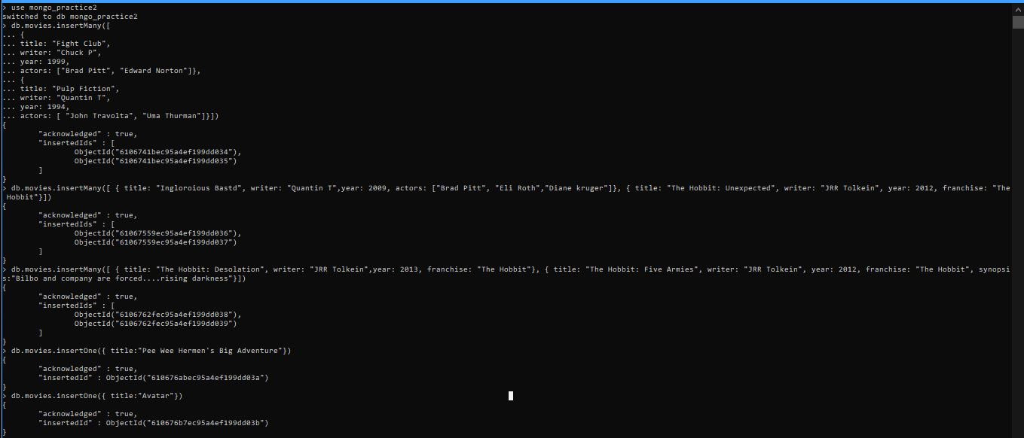

**Query and All Documents**



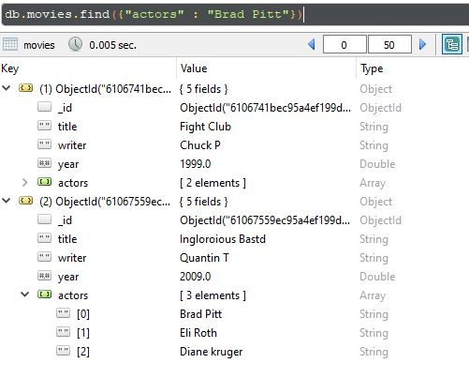

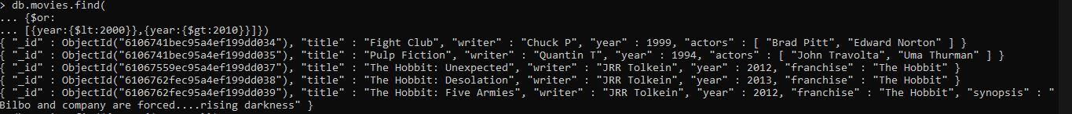

**Update Documents:**

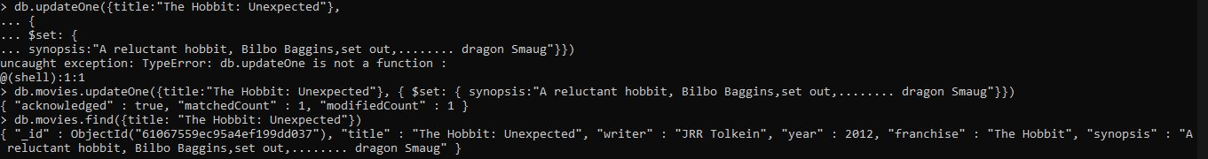

>db.movies.update({_id:ObjectId("6106c186329430635572de67")},{$push:{actors:"Samuel L. Jackson"}})

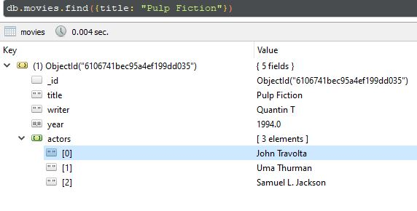

**Text Search**

>db.movies.createIndex({synopsis:”text”})

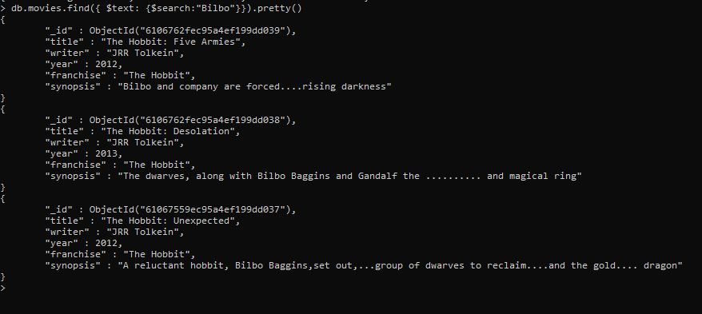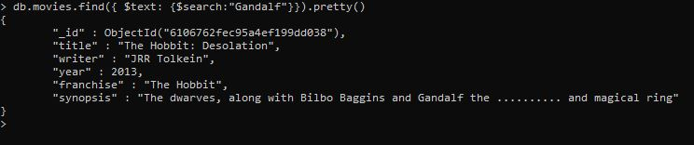

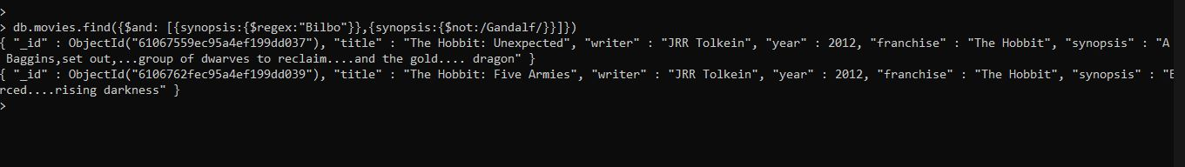

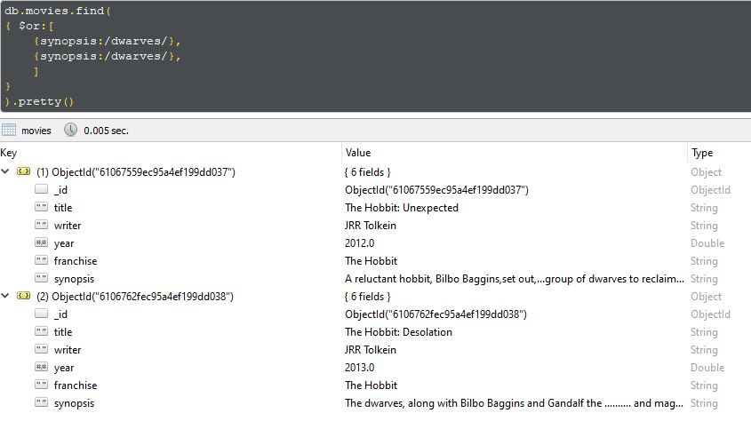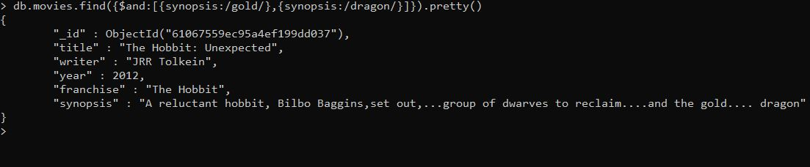

**Delete Document:**

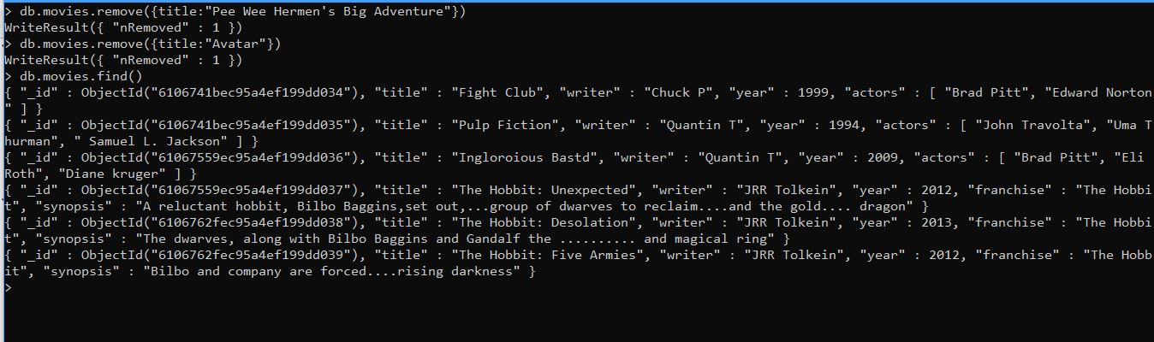

**Relationships:**

